Comparative analysis of Machine Learning Models for Electric Vehicles Price prediction

Muhammad Abdullah
Word Count: 5692

GitHub Name: Muhammad-Abdullah-Jami
Table of Contents
Abstract 6
Introduction 6
Background 7
Dataset 11
Methodology 13
Results and Analysis 19
Conclusion 20
References 21

Abstract
The awareness of adverse effects of carbon dioxide due to internal combustion engine has resulted in exponential growth in the Electric Vehicles EVs Industry. With the increasing consumer market the need for accurate price prediction of Electric Vehicles EVs increased. So different Machine Learning models (Linear Regression, Random Forest, XGBoost and Support Vector Machine (SVM)) were trained to predict the price of Electric Vehicles EVs. Among these models the XGBoost performed the best with the highest R² score of 0.90 while Random Forest Regressor emerged as most consistent R² score 0.85-0.87. Linear Regressor performed moderately with the R² score of 0.755 while Support Vector Regression (SVR) underperformed most likely due to its sensitivity. The best performing model also predicted the price very close to the original prices offering valuable insights for real-world applications in the automotive industry. These findings can revolutionize the price to performance value in the rapidly evolving EV market.

Introduction
The automation industry is going in a transformation shift as the demand for the Electric Vehicles EVs is increasing. Considering the history, the first Electric Vehicle (car) was made in early 19th century but struggled to gain popularity due to limited transport range, high costs, lack of charging capacity and some other factors, especially the competition from internal combustion engine vehicles. Due to the advance technological improvements now 21st century gave the EV’s enough potential to challenge the traditional vehicles. The purpose of this project is to predict the price of EV’s on the basis of the features by using Machine Learning ML models. These include Linear Regression, Random Forest, XGBoost and Support Vector Machine (SVM). The technical indicators like Simple Moving Average SMA, Exponential Moving Average EMA, Moving Average Convergence/Divergence MACD and Rate of Change ROC gave better insights about dataset. The main focus of the project is the analysis of EV’s factors on the price and the evaluation of the Machine Learning ML models on the basis of Mean Absolute Error (MAE), Mean Square Error (MSE), Root Mean Square Error (RMSE) and R² error. These models were used to predict the price of Electric Vehicles as the model asks for input parameters like the top speed (in km/h), the range (in km), the efficiency (in Wh/km), the fast charge speed (in km/h), the number of seats and the acceleration (in seconds), after the user enters the details the model predicts the price of electric car which can be used by any user if he/she wants to buy an electric car with the features he/she requires the estimated price would be deduced using advance machine learning model which is not a simple guess but a factual price that depends on the features provided.
This thesis project solves an important problem “ Which Machine Learning ML or Deep Learning DL model most accurately and reliably predicts the Electric Vehicle price? ” where the models used for the prediction were Linear Regression, Random Forest, XGBoost, Support Vector Machine (SVM) and Time Series Transformer. The models were selected keeping in mind that a diverse number of models should be used so that a variety of predictions can be obtained such as the Linear Regression model is suitable for linear and continues data, while Random Forest is an ensemble based model which spans multiple decision trees for the prediction and selects the best tree for most accurate prediction. Both of these models are basic Machine Learning ML models while XGBoost and Support Vector Regression Machine SVR are complex Machine Learning models that can comprehend data in multiple dimensions to make the predictions. Among these models the Time Series Transformer is a Deep Learning latest model that uses a totally different architecture from usual models and considered more resource hungry and accurate models in the world of artificial intelligence, was used so that the predictions can be assed from almost every nature of model.

Background
Electric Vehicles have captured the market share in the recent years and they are growing rapidly due to many factors like being eco-friendly. As the market share of Electric Vehicles increasing so does the interest of people to what are the prices of the cars with specific features. This paper (Joshua, et al., 2023) sheds light to such need for what should be the prices of such cars in India as they trained Simple Linear Regression model for price prediction. The data they used were primarily focused to the Indian electric car market. The results discussed in the paper are good as the RMSE value of the Linear Regression model was 2624.94. The results also showed a direct relation between the battery capacity and market price. Further details of the research were only available to the paid subscribers of SAE international forum but the available information was also quite useful in a manner that it shows the interests of certain platforms for researching the electric car price prediction with the use of latest Machine Learning ML models.
In recent data it was found that China became top exporter of Electric Vehicles crossing Japan particularly in the electric car market. The increase in the production of these electric cars has decreased the cost so much that the new cars came in direct competition with the used cars. The research paper (Huang, 2024) proposed such idea and trained Random Forst and Gradient Boosting Regression Tree (GBRT) to predict the electric vehicles price. Overall accuracy for circular pricing method was found 82% while the predictions were made with 10 % error margin keeping in mind. The Random forest performed well for low priced electric vehicles while the Gradient Boosting Regression Tree (GBRT) gave good prediction for high priced electric vehicles. In this paper (Huang, 2024) total of 19476 electric vehicles points from Autohome website were scrapped and preprocessing and data cleaning was applied which reduced the raw data to 15583 clean and preprocessed data points. The paper (Huang, 2024) highlighted the key relation of milage and registration time to the prediction instead of other features like vehicles type and propulsion system. These models were evaluated by using the methods like Mean Squared Error MSE, Root Mean Square Error RMSE, Mean Absolute Error MAE and R-squared error. Although the paper (Huang, 2024) used only one data source for modeling but the results were satisfactory and this research align with our goal of training the electric vehicles data by using Random Forest model and gives better insights about the performance of model. The results of the models are shown in the table below.
Table 1 Evaluation Details of paper (Huang, 2024 )
Price Range (Num.) | Method | Lasso Regression | Regression Tree | Support Vector Regression | Random Forest | GBRT
3–10 10 k (5686) | MSE | 5.646 ± 1.490 | 1.113 ± 0.596 | 26.122 ± 4.283 | 0.803 ± 0.428 | 0.837 ± 0.373
 | RMSE | 2.356 ± 0.306 | 1.023 ± 0.257 | 5.094 ± 0.418 | 0.870 ± 0.216 | 0.896 ± 0.187
 | MAE | 1.507 ± 0.236 | 0.676 ± 0.149 | 4.618 ± 0.419 | 0.579 ± 0.137 | 0.623 ± 0.125
 | R² | −0.249 ± 0.322 | 0.755 ± 0.129 | −4.774 ± 0.896 | 0.823 ± 0.092 | 0.816 ± 0.080
10–20 10 k (5719) | MSE | 6.088 ± 2.862 | 3.027 ± 1.428 | 24.609 ± 5.932 | 1.966 ± 1.128 | 1.944 ± 1.200
 | RMSE | 2.401 ± 0.567 | 1.695 ± 0.394 | 4.924 ± 0.601 | 1.352 ± 0.372 | 1.337 ± 0.396
 | MAE | 1.736 ± 0.434 | 1.163 ± 0.227 | 4.423 ± 0.556 | 0.942 ± 0.217 | 0.950 ± 0.238
 | R² | 0.264 ± 0.383 | 0.636 ± 0.189 | −1.938 ± 0.911 | 0.764 ± 0.144 | 0.766 ± 0.152
20–30 10 k (3152) | MSE | 7.811 ± 3.432 | 5.206 ± 2.016 | 10.709 ± 4.278 | 3.482 ± 1.502 | 3.467 ± 1.423
 | RMSE | 2.725 ± 0.621 | 2.245 ± 0.409 | 3.208 ± 0.648 | 1.831 ± 0.360 | 1.829 ± 0.349
 | MAE | 1.959 ± 0.456 | 1.538 ± 0.274 | 2.596 ± 0.560 | 1.263 ± 0.227 | 1.282 ± 0.213
 | R² | −0.114 ± 0.351 | 0.222 ± 0.254 | −0.547 ± 0.432 | 0.472 ± 0.209 | 0.470 ± 0.210
30–50 10 k (1026) | MSE | 47.990 ± 9.399 | 13.678 ± 3.853 | 29.499 ± 3.054 | 9.812 ± 3.372 | 8.522 ± 2.886
 | RMSE | 6.896 ± 0.655 | 3.661 ± 0.522 | 5.424 ± 0.287 | 3.089 ± 0.518 | 2.882 ± 0.465
 | MAE | 5.285 ± 0.417 | 2.541 ± 0.274 | 4.564 ± 0.271 | 2.121 ± 0.290 | 2.012 ± 0.278
 | R² | −0.979 ± 0.203 | 0.444 ± 0.094 | −0.238 ± 0.192 | 0.603 ± 0.088 | 0.653 ± 0.080
3–50 10 k (15,583) | MSE | 9.034 ± 2.828 | 3.471 ± 1.364 | 22.672 ± 4.635 | 2.365 ± 1.080 | 2.281 ± 1.044
 | RMSE | 2.971 ± 0.453 | 1.830 ± 0.348 | 4.737 ± 0.485 | 1.504 ± 0.322 | 1.477 ± 0.316
 | MAE | 1.931 ± 0.348 | 1.152 ± 0.205 | 4.134 ± 0.466 | 0.952 ± 0.192 | 0.968 ± 0.191
 | R² | 0.892 ± 0.032 | 0.959 ± 0.015 | 0.729 ± 0.049 | 0.972 ± 0.012 | 0.973 ± 0.012

The global market of electric vehicles is rising exponential according to the prediction of the paper (IEEE, 2022) is that the global sales of EV to reach 1.5 billion by 2050. The research focuses on the densely populated countries like China and India as they are heavy consumers of electric vehicles and a large amount of population is shifting towards the Electric Vehicles EV’s. The research paper (IEEE, 2022) discuses the role of battery as key point in the prediction of prices of the electric vehicles while other factors like manufacturers also create a little impact on the price prediction. The paper uses the role of Machine Learning ML for the price prediction of Electric Vehicles Ev’s which aligns with our goal of prediction. Although the research focuses on global impact of electric vehicles but limited details on dataset and techniques were give, that lacks feasibility for future studies. As our project has the European details of electric vehicles and their prices a similar research was conducted where different Machine Learning models were trained to predict the prices of electric cars. The paper (Sun, 2023) uses electric vehicles dataset pf 229 records that has feature such as batter capacity, acceleration and size and used multiple Linear Regression Machine Learning models for the prediction of electric cars price. The models used in the training were Bayesian Linear, Boosted Decision Tree, Random Forest, Linear Regression, Neural Network, and Poisson Regression. Among these models the Boosted Decision Tree model achieved the best performance as the evaluation details were better than any other model with lowest Mean Absolute Error MAE of 4722.85 and Root Mean Squared Error of 7509.92 and high R Squared rate of 0.921. The data of these vehicles was one hot encoded for model training. The paper sheds light on how the Electric Vehicles are increasing in Germany an how Machine Learning is predicting the price of the electric cars. The correlation among different features was calculated and the battery capacity and range were mostly effecting the cost as more milage was resulting in high prices. The evaluation of the models with different scores and error rates is given below.
Table 2 Evaluation Details of paper (Sun, 2023)

Regression Model | Dataset | MAE | RMSE | RMAE | RSE | R-Squared
Bayesian Linear | target | 9190.9743 | 13462.2919 | 0.4551 | 0.2548 | 0.7452
Bayesian Linear | one-hot | 9283.0985 | 12675.1867 | 0.4596 | 0.2259 | 0.7741
Boosted Decision Tree | target | 4722.8549 | 7509.9184 | 0.2338 | 0.0793 | 0.9207
Boosted Decision Tree | one-hot | 4943.9819 | 7453.0311 | 0.2448 | 0.0781 | 0.9219
Random Forest | target | 5930.3798 | 9252.8427 | 0.2936 | 0.1204 | 0.8796
Random Forest | one-hot | 7555.2762 | 12551.5692 | 0.3741 | 0.2215 | 0.7785
Linear Regression | target | 9182.9355 | 13459.4273 | 0.4547 | 0.2547 | 0.7453
Linear Regression | one-hot | 9686.0375 | 12577.5997 | 0.4796 | 0.2224 | 0.7776
Neural Network | target | 20181.3479 | 29540.0555 | 0.9993 | 1.2268 | -0.2268
Neural Network | one-hot | 23581.5214 | 34069.1559 | 1.1676 | 1.6318 | -0.6318
Poisson Regression | target | 10145.4532 | 14106.0866 | 0.5023 | 0.2797 | 0.7203
Poisson Regression | one-hot | 10468.6697 | 15620.4181 | 0.5183 | 0.3430 | 0.6570

Similarly there was another implementation of Machine Learning ML models for the prediction of Electric Vehicles EV’s using the Linear Regression model. The paper (Thakkar, et al., 2023) utilizes around 5500 samples from a Kaggle dataset to train and test the Linear Regression model from Python library Sklearn. The data set and the approach aligns with our model as this specific dataset also contains attributes like car name, battery capacity, range, fast charging mode and price etc.. This paper (Thakkar, et al., 2023) used only one model and one dataset for the prediction of prices of Electric Vehicles EV’s but the performance of the model was adequate as the model achieved the accuracy of 75.6% on the testing dataset while the evaluation matrices of the model includes Mean Square Error MSE: 107902152, Mean Absolute Error MAE of 7155.054 and Root Mean Squared Error of 10387.5960 and high R Squared rate of 0.815987. As the error rate is exceptionally high the paper is uncertain how the 75.6% accuracy was achieved as the images added to the paper (Thakkar, et al., 2023) were quite difficult to be read. But it is clear that this paper (Thakkar, et al., 2023) was a practical implementation of Machine Learning ML model more specifically Linear Regression for the prediction of the prices of Electric Vehicles EV’s and provided foundational methodology for applying machine learning to price prediction tasks.

Dataset
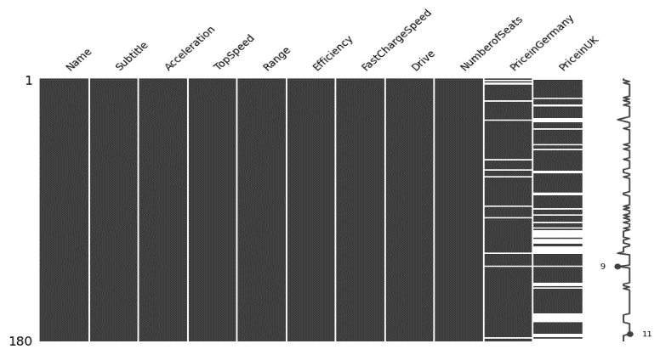
The Dataset of the EV was available publicly at Electric Cars Data Analysis on Kaggle. The dataset was among the list of ethical datasets provided by the university. Further search for the ethical nature of the dataset revealed that before coming to Kaggle the dataset was used from a public dataset gathering website and was scrapped from EV-Database website. No personal or non-ethical information was available or scrapped and the data itself was publicly available for users to compare and research Electric Vehicles EV’s for purchasing purposes. The data set available on Kaggle is just a tabular version of the data available on the mentioned website as the website had the information about the models of cars prices and features collected from the original websites of the respective brands of Electric Vehicles EV’s. As datasets were selected among many datasets university of Hertfordshire provided it strictly follows GDPR Compliance and University of Hertfordshire Ethical Policies. In the thesis project the data was loaded using the kagglehub Python library. This library is ideal for downloading large amounts of Kaggle datasets efficiently and research purposes. The Data was be stored in pandas dataframes. The dataset consists of most affordable electric vehicle’s specifications. Some of the key attributes are Name, Subtitle, Acceleration, TopSpeed, Range, Efficiency, FastChargeSpeed, Drive, NumberofSeats, PriceinGermany, PriceinUK. but the data points of this dataset were not enough as the count was just 180 so a similar dataset with 103 datapoints was also selected so that it can be merged with the current dataset to increase the data points.
Figure 1 Missing Values Before Preprocessing
The second dataset After the application of cleaning and preprocessing techniques on dataset the redundant or missing values was handled and extra text data units from magnitude (numerical values) was removed. The second dataset was publicly available at GitHub. The information as where the data was collected and respected metadata was not given in the discerption or readme file of the GitHub but this data was also in the list of ethical datasets approved by Institute Hertfordshire. Upon looking on the attributes and features of the dataset the dataset does not contain any explicit or personal information violating privacy of any individual or any company as the data just contains the feature of Electric Vehicles EV’s such as Brand, Model, AccelSec, TopSpeed_KmH, Range_Km, Efficiency_WhKm, FastCharge_KmH, RapidCharge, PowerTrain, PlugType, BodyStyle, Segment, Seats, PriceEuro. As both the datasets had a little changings in the naming convention. Both datasets were merged the brand and name were two different columns in the second dataset while in the first dataset it was presented as a single column. While merging both datasets it was kept in mind that the common attributes of both of the datasets should be combined to make one big dataset. So these 8 columns were selected with combined entries of 283 distinct datapoints of unique Electric Vehicles EV’s models.
# | Column | Non-Null Count | Dtype
0 | Name | 283 | object
1 | Acceleration | 283 | object
2 | TopSpeed | 283 | int64
3 | Range | 283 | int64
4 | Efficiency | 283 | int64
5 | FastChargeSpeed | 283 | object
6 | NumberofSeats | 283 | int64
7 | PriceinUK | 283 | float64

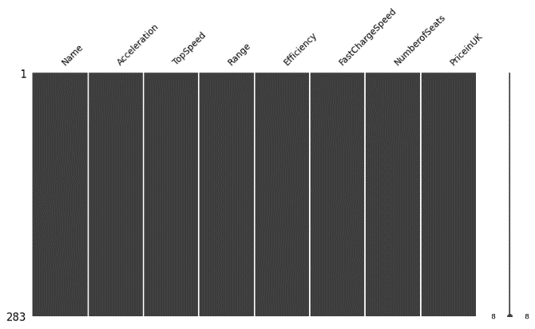
As both datasets were combined on the basis of common attributes. The first dataset had some missing values. For the price category there were two columns for same price but in different currencies. PriceinGermany and PriceinUK and both of them had some missing values 12 and 44 respectively. The currency rate of change was used and at that time as of November 2024 the German price which was in Euros was converted to UK Pounds by multiplying by 0.84 by doing so 32 missing values were handled accurately just by using simple method of price conversion still there were 12 more missing values with no price available so these data was filled with mean price value of the whole dataset. Now that our data was preprocessed and cleaned it was ready for EDA analysis. From this dataset only magnitude numerical values was retained the non numeric data such as units for example top speed is 283.00 Km/h the non numeric values like Km/h were removed so that the data should not cause problem with the model as the Machine Learning models utilizes only numeric features for training and testing.
Figure 2 Data after Cleaning and Preprocessing

Methodology

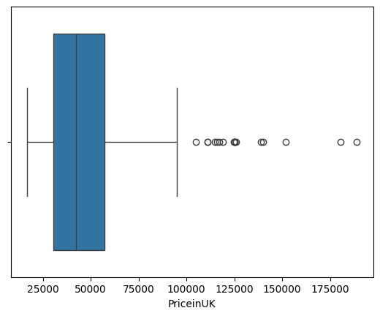
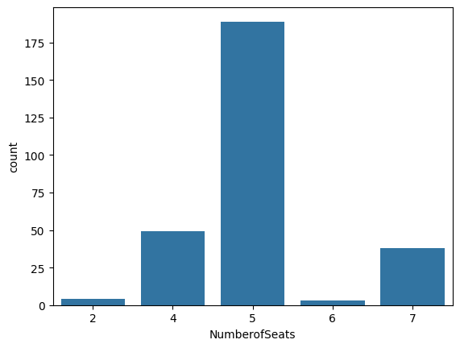
As the data was ready for the Exploratory data analysis EDA matplotlib and seaborn python libraries were used to plot the Histograms to check the normal distribution of the dataset. After that pair plots were made from each attribute with one another to find out which relation was affecting the other relation with what manner and with values. After the Correlation heatmap was generated, it was clear that TopSpeed and Range with values of 0.79 and 0.67 respectively were the most effecting features to the Price in Electric Vehicles EV’s. The Correlation heatmap is as follows.
Figure 4 Price Distribution
Figure 3 Number of Seats Distribution
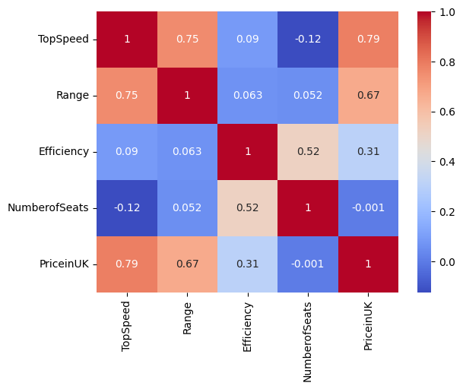
Figure 5 Correlation Heatmap
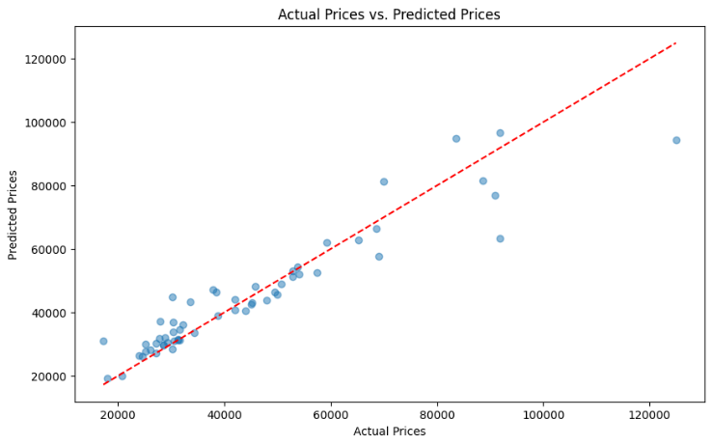
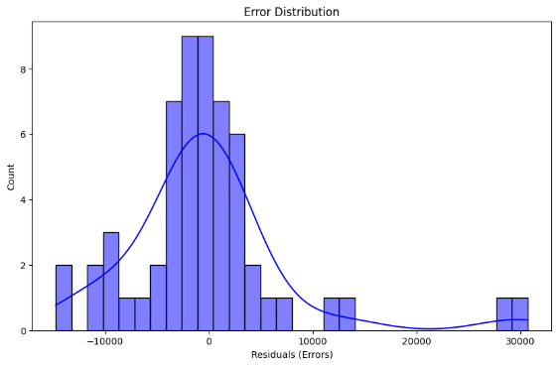
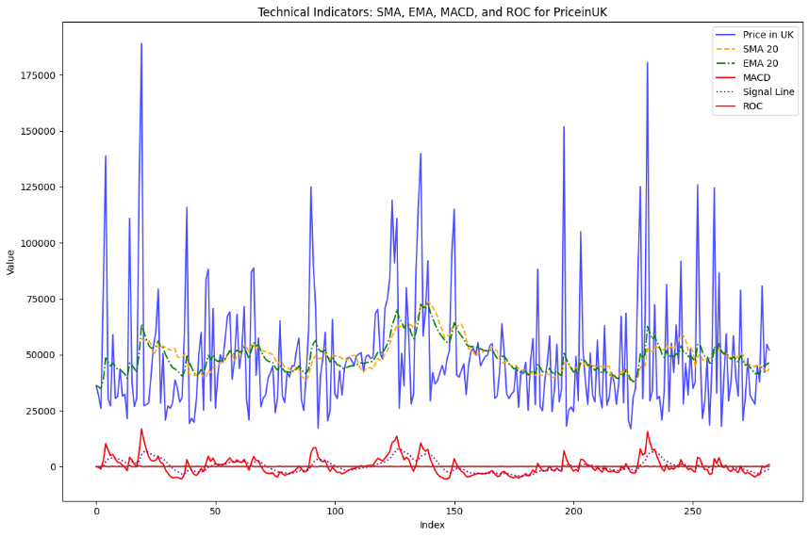
There are always hidden patterns in datasets technical indicators help detect those patterns. While building ML models we can use these indicators as features, which help us in understanding nature of datasets eventually resulting in better trained ML Model. Feature engineering techniques such as technical indicators like Simple Moving Average (SMA), Exponential Moving Average (EMA), Moving Average Convergence Divergence (MACD), Rate of Change (ROC) were applied for better insight of the dataset. As we know that feature engineering along with preprocessing plays crucial role in more accurate and precise predictions as ML models perform better on clean processed data rather than raw text. For Exploratory data analysis EDA as discussed different plots were made for understanding the correlation among features and to analyze the distribution of the features. As the technical indicators data was merged with the original data the dataset was ready for model training. The plot of feature engineering also gives insight as how the technical indicators like Simple Moving Average (SMA), Exponential Moving Average (EMA), Moving Average Convergence Divergence (MACD), Rate of Change (ROC) have effect on the price. But their crucial role was for the Machine Learning ML models because the complex changing values a human cannot make relations but Artificial Intelligence model can make the relations and find hidden patterns making the predictions more accurate and effective. All of this code was developed in Google Colab and GitHub was used for commenting all progress made during project to track the changes done in the code throughout the project. In this way all progress is documented and accessible to others. The ReadMe file gives overview of the project, it will contain instructions to run code and other useful descriptions. Other than GitHub to ensure data safety frequent backups was made on cloud storage and local storage. The GitHub repository link is attached at the beginning of the report.
Figure 6 Error Distribution Histogram
Figure 7 Actual vs Predicted Price Scatter Plot
Figure 8 Technical Indicators
As the Machine Learning models were to be implemented, I used Linear Regression, Random Forest, XGBoost, Support Vector Machine (SVM). After literature review the above mentioned models were selected as it was expected that these models will be resulting in better predictions as the authors of the mentioned research papers used these models and their results were more than satisfactory. So, the Random Forest Regressor model was selected due to its ensemble based robust nature and the model didn’t need any scaling of data as all of our data was present in numeric form which was enough for the model. The model was created in a function so that the hyperparameters can be provided as parameters of the function for easy experimentation of the hyper parameters.
Random Forest is an ensemble-based model that utilises multiple tree structure for classification etc it also excels in regression tasks. Its technique of constructing multiple decision trees improve accuracy and reduces overfitting. As Random Forest Regressor spans multiple trees for learning and analyzing the hidden patterns this nature of the model was against overfitting as we know that we had very low datapoints of the Electric Vehicles EVs because not so many models of Electric Vehicles EVs are manufactured yet so this model was not able to overfit on this dataset. During the initial model training the data was split into ratio of 80:20 using the Sklearn library of “test train split” and trained with 100 estimators the model was evaluated and excellent performance results were obtained as Mean Absolute Error (MAE): 4865.43, Mean Squared Error (MSE): 60615169.17, Root, Mean Squared Error (RMSE): 7785.57, R-squared (R²): 0.8764. The error rate is used for the evaluation low error rate means the model performance is good it means that lower the error rate as Mean Absolute Error (MAE), Mean Squared Error (MSE), Root Mean Squared Error (RMSE) the better is the model performance. So the model was again subjected to the parameter tuning for better results. After the parameter tuning experiment the model with best R Squared value and lowest error rate was used to predict the price of Electric Vehicles EVs. The R² score works in range it means basically its value ranges from 0 to 1. If the value is near to 1 it means the model prediction is more accurate the value near to 0.5 represents the average performance of the model while the value of 0 shows worst prediction made by model. This is the normal range but sometimes the evaluation results in negative values. The negative value indicates that the model is performing bad then worse meaning for the prediction the model is just using the average or mean of all the data not utilizing the efficient learning of the hidden patterns. The R² score of the model was 0.8764. which shows the variance pf 87, it is considered as a very good number but the variance in 90’s is preferable. The input given to the model was TopSpeed: 150 km/h, Range: 335 km, Efficiency: 173 Wh/km, FastChargeSpeed: 210 km/h, NumberofSeats: 5, Acceleration: 7.3 seconds and the output result was £30,015.72 which is very close to the original value of 35,683.85.

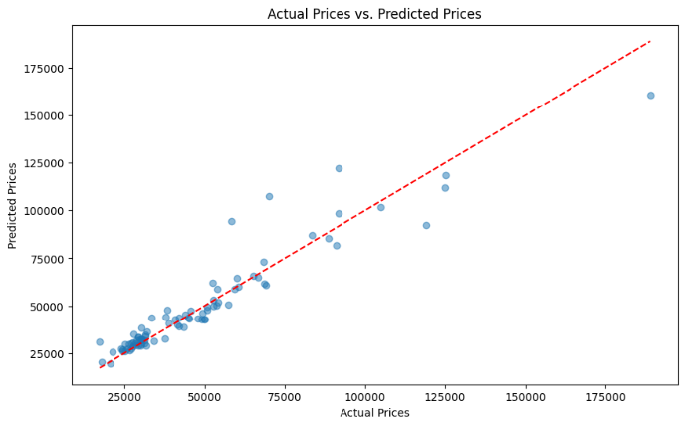
After that the XGBoost regression model was implemented which is a very famous gradient boosting algorithm. XGBoost is a supervised ML model that is used for classification and predicting tasks. It can efficiently make linear and nonlinear relationships among features. This makes XGBoost optimum for our regression task for EV’s datasets. It is famous for its speed and performance for large datasets. The model’s ability to process structured data was suitable as it saves model from over fitting. The dataset for this model was divided into features X and target y and with the splitting ration of 80:20 using the Sklearn library of “test train split”, estimators: 100, learning rate 0.001 and maximum depth of 5 the model was trained and evaluated the R squared value of 0.646 shows 64.6% variance which is not a good performance value so the model was subjected to hyperparameters tuning to get best results and the R Squared rate was increased to 0.90. So during the training excellent performance results were obtained as Mean Absolute Error (MAE): 9889.47, Mean Squared Error (MSE): 173,436,626.68, Root, Mean Squared Error (RMSE): 16,654.52, R-squared (R²): 0.646. The error rate is used for the evaluation low error rate means the model performance is good it means that lower the error rate as Mean Absolute Error (MAE), Mean Squared Error (MSE), Root Mean Squared Error (RMSE) the better is the model performance. So the model was again subjected to the parameter tuning for better results. After the parameter tuning experiment the model with best R Squared value and lowest error rate was used to predict the price of Electric Vehicles EVs. The R² score works in range it means basically its value ranges from 0 to 1. If the value is near to 1 it means the model prediction is more accurate the value near to 0.5 represents the average performance of the model while the value of 0 shows worst prediction made by model. This is the normal range but sometimes the evaluation results in negative values. The negative value indicates that the model is performing badly then worse meaning for the prediction the model is just using the average or mean of all the data not utilizing the efficient learning of the hidden patterns. The R² score of the model was 0.90. The input given to the model was TopSpeed: 150 km/h, Range: 335 km, Efficiency: 173 Wh/km, FastChargeSpeed: 210 km/h, NumberofSeats: 5, Acceleration: 7.3 seconds and the output result was £30,015.72 which is very close to the original value of 35,683.85 . The predicted price was £31923.83 which was very close to the original price of £ 35,683.85.
Figure 9 XGBoost Scatter plot
Support Vector Regression (SVR) is a supervised learning model that creates hyperplane (many dimension lines) for classification and regression datasets. SVM is great for high dimensional datasets. What makes it useful is its straightforward classification and easy setup with remarkable accuracies. Support Vector Regression (SVR) was used with the hyperparameters values such s Kernel set to Radial Basis Function (RBF), test size of 20% and the model results of R squared error was -0.002 which explains that the SVR model underperformed or performed worst for predicting the price values. The evaluated performance results were obtained as Mean Absolute Error (MAE): 16,831.60, Mean Squared Error (MSE): 491,494,574.28, Root Mean Squared Error (RMSE): 22,169.68, R-squared (R²): -0.002. The error rate is used for the evaluation low error rate means the model performance is good it means that lower the error rate as Mean Absolute Error (MAE), Mean Squared Error (MSE), Root Mean Squared Error (RMSE) the better is the model performance. So the model was again subjected to the parameter tuning for better results. After the parameter tuning experiment the model with best R Squared value and lowest error rate was used to predict the price of Electric Vehicles EVs. The R² score works in range it means basically its value ranges from 0 to 1. If the value is near to 1 it means the model prediction is more accurate the value near to 0.5 represents the average performance of the model while the value of 0 shows worst prediction made by model. This is the normal range but sometimes the evaluation results in negative values. The negative value indicates that the model is performing badly then worse meaning for the prediction the model is just using the average or mean of all the data not utlising the efficient learning of the hidden patterns. The R² score of the model was 00.8764. The input given to the model was TopSpeed: 150 km/h, Range: 335 km, Efficiency: 173 Wh/km, FastChargeSpeed: 210 km/h, NumberofSeats: 5, Acceleration: 7.3 seconds and the output result was £37,290.35 which far greater then the original value of 35,683.85. Further experimentation were made but they were unable to increase the performance of the model.
After the unsatisfactory performance of SVR the Linear Regressor model was trained by fitting a straight line relationship between the features. Linear Regression is ML model that uses statistical methods to create relationship between dependent variables such as prices to independent variables like various specifications and predicts values. It works for linear as well as complex relationship datasets. The model parameters were set to usual values including train test ration of 80:20 and random state 42. And the R Squared value of the model was 0.755. The model was evaluated and excellent performance results were obtained as Mean Absolute Error (MAE): 8373.08, Mean Squared Error (MSE): 120,169,585.87, Root Mean Squared Error (RMSE): 10,962.19, R-squared (R²): 0.755. The error rate is used for the evaluation low error rate means the model is good it means that lower the error rate as Mean Absolute Error (MAE), Mean Squared Error (MSE), Root Mean Squared Error (RMSE) the better is the model performance. So the model was again subjected to the parameter tuning for better results. After the parameter tuning experiment the model with best R Squared value and lowest error rate was used to predict the price of Electric Vehicles EVs. The R² score works in range it means basically its value ranges from 0 to 1. If the value is near to 1 it means the model prediction is more accurate the value near to 0.5 represents the average performance of the model while the value of 0 shows worst prediction made by model. This is the normal range but sometimes the evaluation results in negative values. The negative value indicates that the model is performing badly then worse meaning for the prediction the model is just using the average or mean of all the data not utilizing the efficient learning of the hidden patterns. The R² score of the model was 00.8764. The input given to the model was TopSpeed: 150 km/h, Range: 335 km, Efficiency: 173 Wh/km, FastChargeSpeed: 210 km/h, NumberofSeats: 5, Acceleration: 7.3 seconds and the output result was £30,795.95 which is very close to the original value of 35,683.85 a very similar price range as predicted b XGBoost model. Further parameter tuning was applied to increase the model performance for the prediction of Electric Vehicles EVs. After using these basic and advance Machine Learning model that uses similar techniques like tree based or linear line base models the time series transformer is advance Deep Learning Model which is based on a totally different method transformers was applied but due to bad performance on a very short dataset it was discarded. Among these models XGBoost performed the best then Random Forest Regressor performed second best while the Liner Regressor was third and the worst performance was achieved by model Support Vector Regression (SVR).

Results and Analysis
The thesis project involved the evaluation of four machine learning models Linear Regression, Random Forest Regressor, XGBoost, and Support Vector Regression for predicting the prices of Electric Vehicles (EVs). And for the evaluation four error rates used were of Mean Absolute Error (MAE), Mean Square Error (MSE), Root Mean Square Error (RMSE) and R² error. Below is the summary table of every model used with hyperparameters tuned.

Table 3 All Model Evaluation Summary
Model | Parameters | MAE | MSE | RMSE | RR² | Predicted Price (UK)
Random Forest (1) | ts=0.2, nst=100 | 4865.43 | 60,615,169.17 | 7785.57 | 00.8764 | £30,015.72
Random Forest (2) | ts=0.3, nst=150 | 6148.21 | 111,144,889.69 | 10,542.53 | 00.8619
Random Forest (3) | ts=0.3, nst=100 | 6300.17 | 115,259,793.17 | 10,735.91 | 00.8568
XGBoost (1) | ts=0.2, n_estim=100, lr=0.01, dep=5 | 9889.47 | 173,436,626.68 | 13,169.53 | 00.646 | £31,923.83
XGBoost (2) | ts=0.3, n_estim=100, lr=0.01, dep=5 | 10,770.24 | 277,372,959.51 | 16,654.52 | 00.655
XGBoost (3) | ts=0.3, n_estim=100, lr=0.1, dep=5 | 5282.66 | 80,744,404.57 | 8985.79 | 00.900
Support Vector (1) | ts=0.2, kernel='rbf' | 16,831.60 | 491,494,574.28 | 22,169.68 | --0.002 | £37,290.35
Support Vector (2) | ts=0.3, kernel='rbf' | 19,116.51 | 831,890,720.02 | 28,842.52 | --0.033
Support Vector (3) | ts=0.35, kernel='rbf' | 19,338.60 | 800,865,632.47 | 28,299.57 | --0.013
Linear Regression (1) | ts=0.2, random_state=42 | 8373.08 | 120,169,585.87 | 10,962.19 | 00.755 | £30,795.95
Linear Regression (2) | ts=0.3, random_state=42 | 9063.40 | 244,349,950.62 | 15,631.70 | 00.696
Linear Regression (3) | ts=0.3, random_state=1 | 9890.34 | 290,493,466.51 | 17,043.87 | 00.687

Among all the models evaluated, XGBoost appeared as the top performing model with lowest error rate RMSE of 8985.75 and highest R² score of 0.90 explaining the variance of 90% while predicting the price of test example of Electric Vehicles its prediction was £31,923.83 while the original price was. £35,683.85. Then the Random Forest Regressor performed second best with R² score of 0.87 then comes as the third best performer the Linear Regressor model with the R² score of 0.755 while Support Vector Regression (SVR) performed the worst with the R² score of -0.01 as the negative values shows the total opposite and useless predictions with the comparison of original value as if the model is generating random values instead of learning the hidden patterns and predicting while utilizing them. It was likely due to the fact that the data was short and simple with multiple ranges as different features results in totally different price so SVR was unable to learn well from the data. Overall, the results showed the advance Machine Learning model especially XGBoost performed well in one example of parameter tuning while the Random Forest performed near best more the 0.85 R² score in every parameter tuning experiment. These models can effectively and accurately predict the price of Electric Vehicles EVs giving better insights in the new automotive industry.

Conclusion
The motive of this research was to use Machine Learning model to predict price of Electric Vehicles EVs. Among all the models trained and evaluated XGBoost performed best with the highest R² score while Random Forest Regressor emerged as most consistent with R² score. Linear Regressor performed moderately with the R² score of 0.755 while Support Vector Regression (SVR) underperformed most likely due to its sensitivity. The predicted prices were very close to the real world price values expressing the capability of Machine Learning finding its application in real world problems. This research is useful for both consumers and industrialist as the price prediction with respect to the features gives a consistent rate of price to performance. The future research can use more recent data and latest Deep Learning models for the price prediction.

References
Huang, S. Z. Y. H. J. Z. E. a. X. T., 2024. Analysis of Circular Price Prediction Strategy for Used Electric Vehicles. Sustainability, 16(13).
IEEE, A., 2022. Global Distribution and Price Prediction of Electric Vehicles Using Machine Learning. Hubli, IEEE.
Joshua, D. R., J. Samson, I., P. Karthik & M. Jayanthi, 2023. Prediction of Electric Vehicle Price in India using Simple Linear Regression. International Conference on Trends in Automotive Parts Systems and Applications, Issue N/A, p. 1–6.
Sun, M. Y. J. a. Y. P., 2023. Price Prediction and Feature Importance Analysis of German Electric Vehicles Based on Boosted Decision Tree Model. s.l., EMFRM 2022, BCP Business & Management.
Thakkar, et al., 2023. Price Prediction of Electric Vehicles. International Journal of Research Publication and Reviews, 4(4).

